Cleeng’s iOS SDK Documentation

Target Audience:
Target audience of this iOS SDK documentation, is/are application developer(s) from Cleeng’s video publisher clients & who would like to create an iOS application with worrying less about the application’s integration with Cleeng API platform.

Pre-requisites:
It is assumed that the user of this SDK would already know iOS based application development/programming environment/terminology used. Also it is noted that this SDK does not present complete features/capability that Cleeng platform. You are encouraged to visit Cleeng’s API documentation & add value to this SDK.

Integrating SDK in your Project:
To align with iOS terminology, we will refer the SDK as “framework” here onwards.
Once you download the framework application from Cleeng’s github location, you need to build the application as you do with iOS application environment. It will generate the framework file into the Products folder as display in following fig:
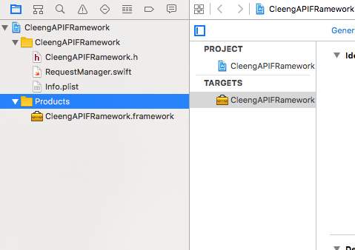
Figure 1: Generating Framework file

- Now right click on this framework file under the Products folder and select Show in Finder options. As shown in following Fig:
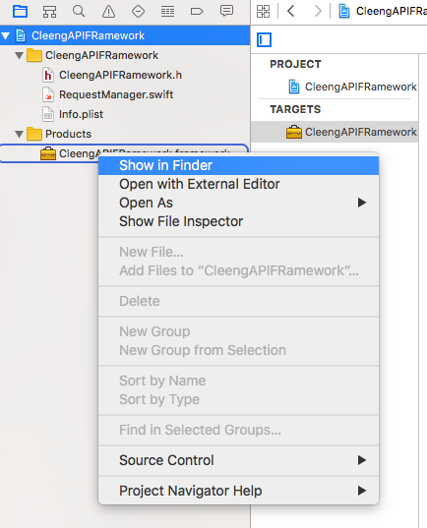
Figure 2: Generating the framework file

- Now select the framework file from there as showing in following Figure and paste it at any location where you want.
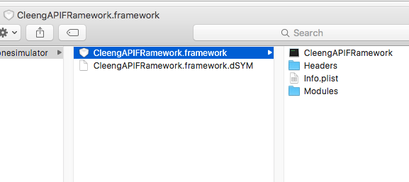
Figure 3: Selecting the framework file

- Now go to your project, create a folder with name SDKs and put this framework file into this folder. As shown in Fig:
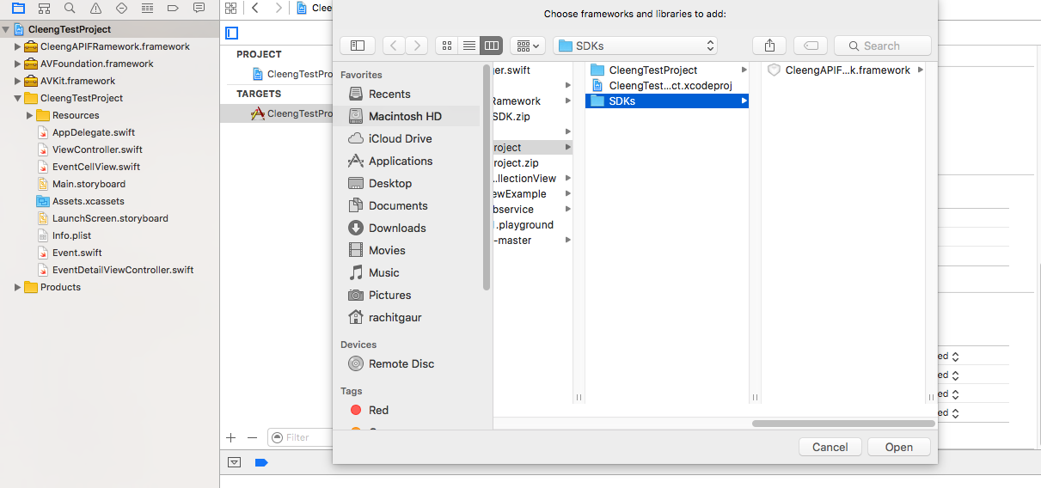

- Now it’s time to add this framework into your project. Go to the “Linked framework and Libraries” click on the + button to add new framework. It will open a dialogbox where click on “Add Other…” button. It will open the finder here browse to your project and select the framework from the SDKs folder and click open. It will add the framework into your application. As shown in following Fig:
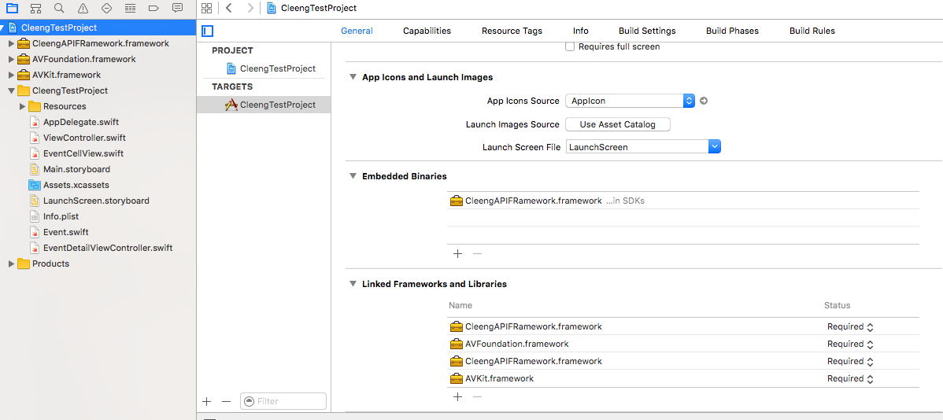

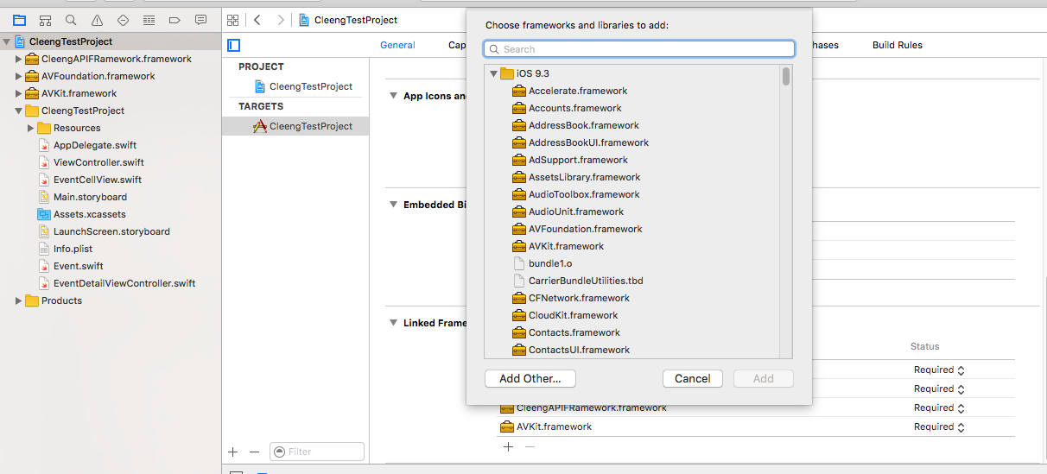
Now go to your AppDelegate.swift file and paste the following lines followed by the “import UIKit”
import CleengAPIFRamework
let theAsyncManager = AsyncManager()
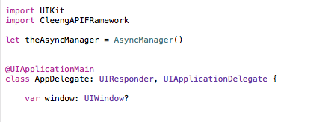
Now you are ready to use this framework into your project.

Methods in Framework:
Framework has two methods as follows:
- getCustomerTokenByTransactionID
- getAccessGranted

How to use:
getCustomerTokenByTransactionID
This method will accept one parameter named receiptNumber and will return the completion handler with data, response, error parameters. You can parse and use them accordingly in your app.
getAccessGranted
This method will accept three parameters named customerToken (received by getCustomerTokenByTransactionID), eventOfferID, and deviceID. It will return the completion handler with data, response, error parameters. You can parse and use them accordingly in your app.

Terminology
receiptNumber : The transaction number / receipt number that end customer receive in their email notification sent by Cleeng.
eventOfferID : The offer Id for an event as available in Cleeng Admin
deviceID : The deviceID identifier of user device. If needed, the actual deviceID can be encrypted to another unique string to use.

